Shatenova Aelin
My page is Regions. My work includes:
- creating the HTML structure;
- adding information about the seven regions;
- creating the region cards;
- adding background images to the cards;
- creating the regions timeline;
- creating the FAQ section;
- styling the page with CSS;
- using CSS Grid for the region cards;
- using reusable CSS selectors;
- connecting the page with the shared navigation;
- working with Git and GitHub.
- The page starts with a standard HTML5 document structure.
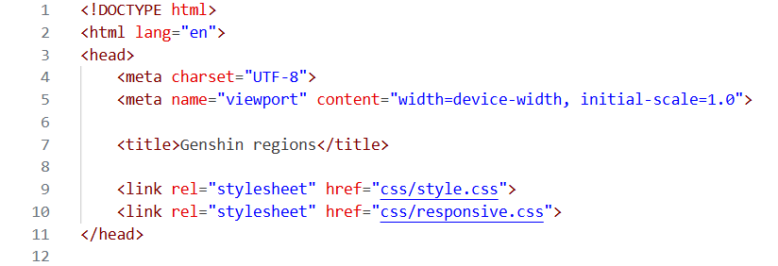
- The navigation contains links to the main pages.
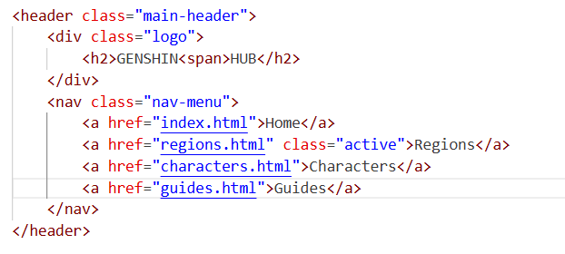
- The first section of my page is regions0.
The <h1> is the main page heading. The paragraph gives the visitor background information about Teyvat. There is only one main h1 on the page, followed by lower-level headings.
- The main part of the page is the Explore Teyvat section.
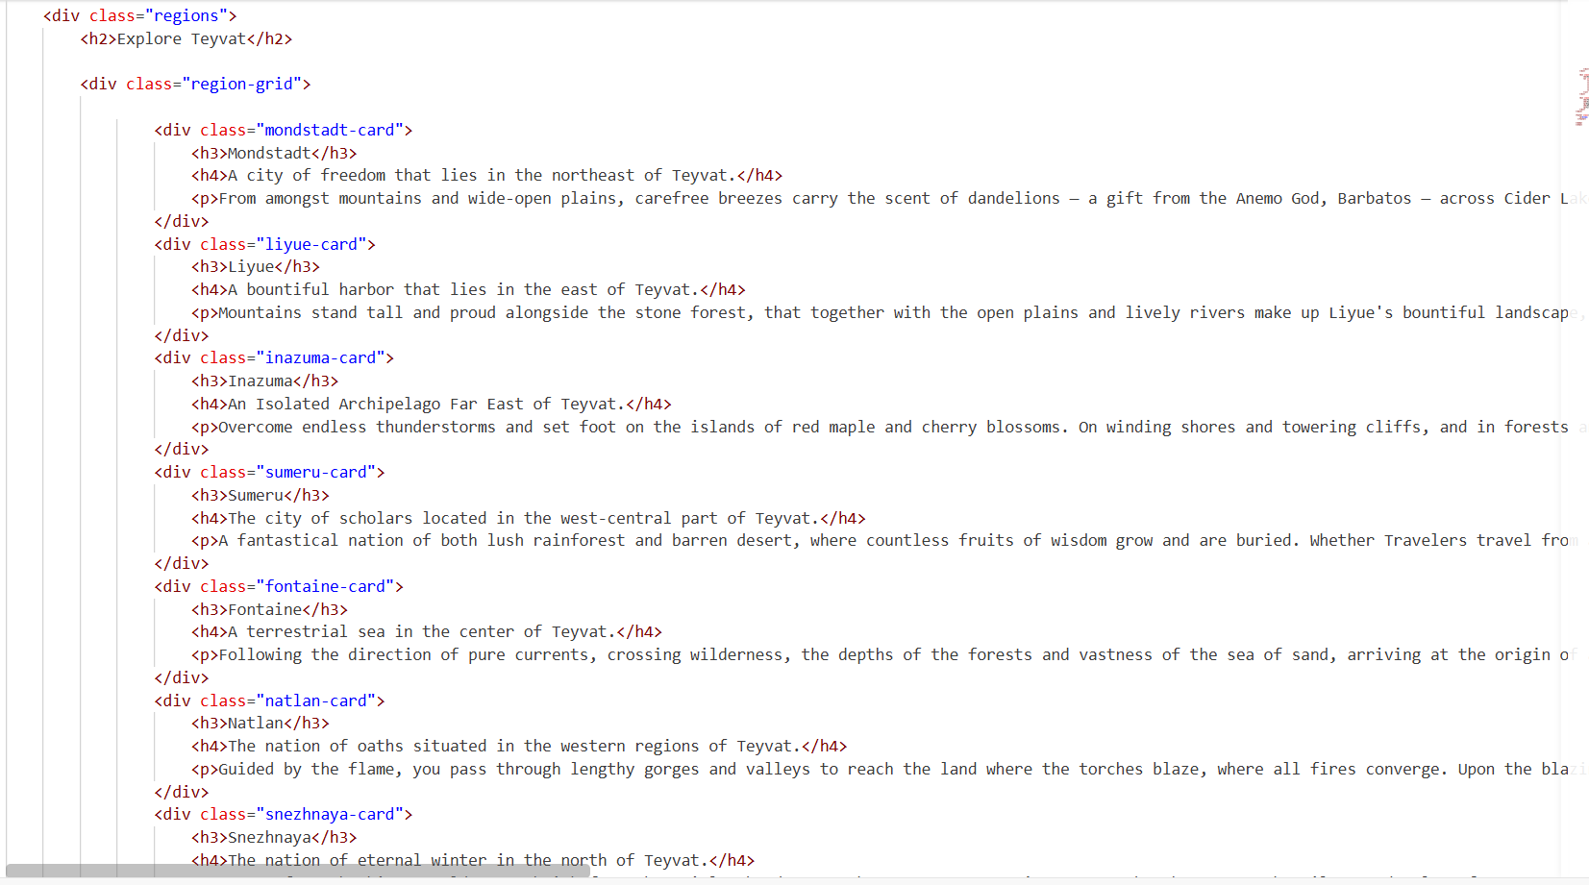
Inside the grid there are seven region cards. Each card has:
The <h3> contains the region name. The <h4> contains a short description. The <p> contains more detailed information.
- The CSS rules for .regions0 establish a centralized content container for the main regions page header
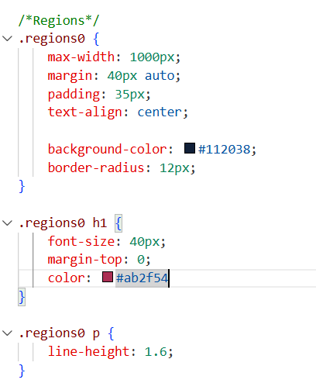
- I used CSS Grid for the region cards.
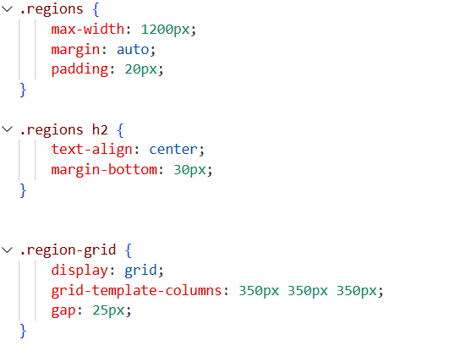

display: grid changes the container into a Grid layout. Gap creates space between the cards.
- All region cards use the same reusable CSS.

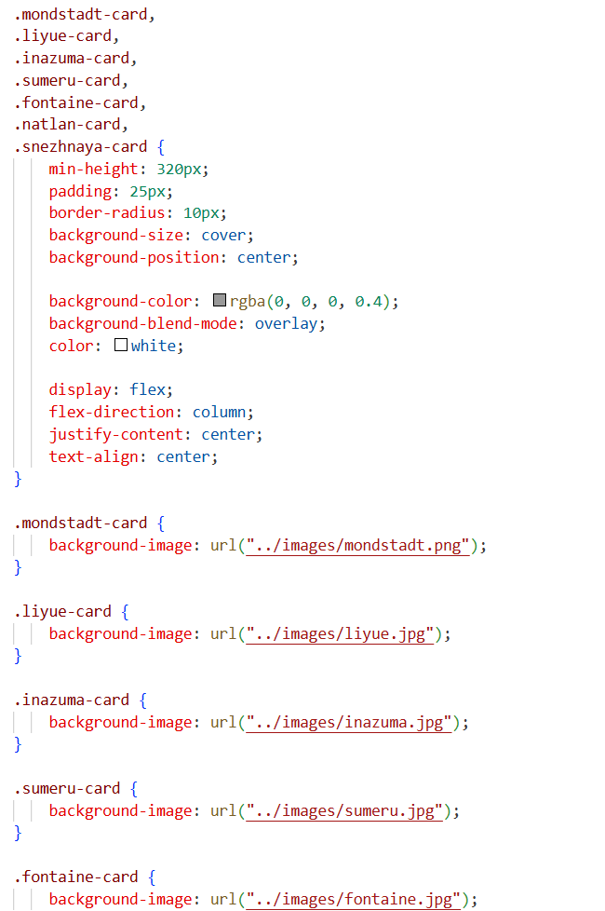
- The page also contains a timeline:

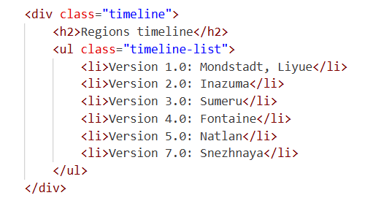

I used an unordered list because the timeline consists of separate information items.
- The page also has an FAQ section:

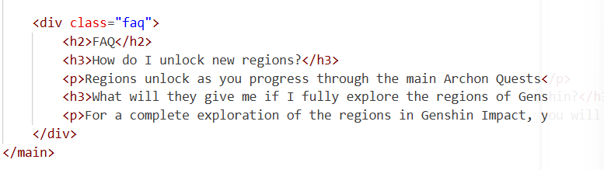
- To ensure consistent design across shared components, the .timeline and .faq blocks share reusable layout classes
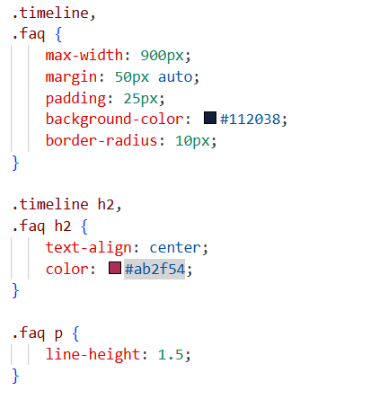
During this assignment, I learned how to create a multi-page website using HTML and advanced CSS. I practiced using Flexbox for one-dimensional layouts and CSS Grid for two-dimensional layouts. I also learned how to create reusable CSS classes, use background images, create overlays, organize content into cards, and make the website responsive.

